DRAFT

Funeral Response Guide
for the

Public Information Officer
2017

Introduction

Hello, friend,

This guide was compiled in response to funerals of five officers and one firefighter that happened between 2013 and 2017, six heartbreaking incidents of those who serve and protect being laid to rest.

Those who are left behind carry an enormous burden to honor both the dead and the living with a service paying tribute to the fallen. It seems impossible to organize something like this, especially if you are in the depths of grief, but it can be done.

You are not alone in this. Friends are here.

This guide has been produced for two reasons:

1. We want to help you plan if fate would have your agency lose one of its own in the line of duty. You need to know what to look for, what to ask for and what help is available.

2. We want you to know what to expect if you are responding as a volunteer. This guide covers what needs to happen in order for a funeral to serve its purpose and in order for the public information officer from the grieving agency to appropriately mourn.

We are great when we work together. Please remember sensitivity, tact and kindness, with some sacrifice, with accomplish great things.

With love,

The Utah PIO Association

Table of Contents

How to request help - Contacts Page 4
A typical timeline Page 6
Funeral Assignments Page 8
Position checklists

TEMPLATES
Media instructions Page 12
News release, perpetrators ID'd Page 15
PIO help needed email Page 17
Talking points for the family spokesperson Page 18

ATTACHMENTS

Venues
Shrouded badge

How to request help - Contacts

To start requesting PIOs
Utah PIO Association

2017-18 PIO leadership:

Roxeanne Vainuku, president
801-503-7678
roxeanne.vainuku@wvc-ut.gov

Ben Horsley, vice president
801-698-5335
bhorsley@graniteschools.org

Christina Judd, officer-at-large
801-718-9911
christina.judd@slcgov.com

Wade Mathews, past president
801-834-9741
wmathews@utah.gov

Joe Dougherty, secretary
801-538-3738
801-664-1530
jdougherty@utah.gov

PIOs who have gone through this since 2013

Draper City
Maridene Alexander
801-831-7224

Salt Lake City Fire
Capt. Mark Bednarik
801-540-7195

Unified Police and Salt Lake County Sheriff's Office
Sgt. Cammie Skogg
801-839-9835
Chief Deputy Justin Hoyal
801-884-7024

Utah County Sheriff's Office
Sgt. Spencer Cannon
801-404-1912
Utah Highway Patrol
Sgt. Todd Royce
801-556-8261

West Valley City Police
Roxeanne Vainuku
801-503-7678

Traffic information/collaboration
UDOT

Lisa Miller
Traveler Information Manager
Traffic Management Division
801- 887-3761
801-514-1996
lisamiller@utah.gov
Twitter: @UDOTTraffic
24/7 Traffic Operations Center – 801-887-3700
Tc-controlroom@utah.gov

Extra American Flags

Fred Ross
Utah Transit Authority Chief of Police
801-287-2601
Email: rfredross@msn.com
Cell phone: 801-301-0552

A typical timeline - What to expect

- Notification: This is when your department learns one of the worst fears has come to pass. Every normal thing is upset and emotions are running very high. In most cases, the incident that caused an officer’s death is over quickly. And even though an investigation is ongoing, the mourning and planning begin immediately. Consider this the start of a one-week countdown clock to a funeral. But don’t forget to be a human and mourn, as well.
- Media inquiries: These are going to come from everyone who covers your jurisdiction. Prepare to hold a press conference as soon as possible after the next of kin have been notified. It’s possible that these inquiries can come even before you are officially notified.
This is when you will likely release official photos are record of service of the officer to the media. So gather those items now for your department.
- First contact from the PIO Association: At some point after two hours of the news being out, the PIO Association will send a PIO to you to be your personal assistant. This is someone who can help take notes, keep your phone charged and report back to PIO Association leadership with situation updates.
- After the first two days, media inquiries start to drop off, but will pick up as soon as your have a funeral date, time and location. Don’t forget that around day two or three afterward, someone will organize a candlelight vigil, likely near your agency. It may be useful to provide the officer’s car somewhere where people can leave flowers and notes of condolences. In the early stages of funeral planning, let the PIO Association gather your team, soliciting volunteers to take on a number of duties and make most of the assignments. We’ll consult with you before final assignments go out.
- Funeral planning goes into 5th Gear: This is where you are having regular meetings and reviewing everyone’s assignments. As the lead PIO for your agency, you should have regular contact with your chief and the family liaison to continue understanding the family’s wishes while also providing advice to them about how things need to work. The program should be well under way at this point and any parking placards should be provided to your PIO team. Don’t forget to coordinate with UDOT for any traffic needs.
Order food for the funeral venue. The funeral is going to be a long day.
- Media briefing: Prepare materials and Google or other shareable maps and notify the media of the funeral plans, staging at the service, availability of carrying the funeral service live, travel routes, staging at the cemetery and other important items during an in-person meeting. This information should also go out on social media and on your website.
- Day before the funeral – Viewing: You will likely need to staff the viewing, depending on the location. You can use your own staff or a volunteer PIO for that. Continue reviewing plans. Make sure there is food and water available at the funeral venue.
- Day of the funeral: This is a long day, likely the longest day. You'll need your big team in place. Have your phone charged and carry a power pack charger with you. Have a briefing with PIOs on site about 90 minutes before the service begins. The body will likely arrive a couple of hours before, depending on if there’s a viewing at that venue or not. Try to let your PIO team do their jobs so you can focus on the moment.
- Afterward: Rest and sleep. Then take time to run analytics on your social media efforts, review news clips and maintain contact with the family spokesperson or representative. Plan to hold an after-action review of the operation, even if it’s on the phone, and make sure someone takes notes so this process can be further refined the next time.

Funeral Assignments List (Large team)
You may not need to make all of these assignments

Planning needs in advance (See Advanced planning details)
Find out family wishes
Viewing
Venues
Cortege/Processional
Assistant PIOs
Graveside services
Social media/Website/Graphic Design
Public information plan
News media
Maps
Program
Badging

-- Day before funeral --

Viewing division
Production unit
Photography (if needed)
Videography

Social media unit
(if needed)

Media unit
Media relations at viewing and during the day

Funeral Assignments List - continued
Public unit
Receive gifts (All of this may be done by funeral home)
Door greeters
Programs
-- Day of funeral --

Leadership
Lead PIO
Assistant PIO (or 2)
Family liaison or PIO who communicates with family liaison
Facility PIO
Liaison with person conducting

Funeral service division
Production unit
Photography inside
Videography inside
Photography outside
Videography outside

Social media unit
Twitter at funeral
Facebook at funeral

Media unit
Media relations at funeral
Line up spokespeople from within or other agencies
Up top or floor level

Public unit
Receive gifts
Door greeters
Ushers
Programs
Explorers
VIPs

Family unit
Family privacy protection at funeral

Funeral Assignments List - continued

Funeral cortege division
Production unit
Photography procession
Videography procession

Social media unit
Social image sharing from procession

Graveside division
Production unit
Photography graveside
Videography graveside

Social media unit
Twitter at graveside
Facebook at graveside

Media unit
Media relations at graveside

Family unit
Mobile command unit at funeral

Advanced planning details

Family/Employer
Find out family wishes -- Venue, program speakers, media interviews, etc.
Identify family spokesperson
Assign officer to the family, someone close to the family
Is there a secondary employer? Coordinate information and plans with them

Viewing venue
Private family viewing
Public viewing
Private viewing for fellow officers and employees

Funeral venue
Find out family wishes
Is the venue big enough? Is there enough parking?
Is there a cost?
Easy access to the facility?
Do you have maps of the facility (Seating charts and Google)
Room for media to stream the funeral live?
Transportation/parking plan

Funeral cortege (Processional)
Route plan
Assistance from local law enforcement
Flags along route

Graveside services
Location
Maps
Parking
Media staging
Expect the Patriot Guard Riders (motorcycles)

PIOs
Rally PIOs to help
Give them assignment sand copies of venue planning and media planning guides
Briefing -- invites, location, instructions

Social media/Website
Set up official hashtag
Appropriate updates to website, Twitter and Facebook
PIO help will be needed
Shrouded badge design

Public information plan
Media releases
Maps for the public
All media and social media sources

News media
Media advisory about funeral plans
Media advisory about media briefing
Media briefing
Media plan production
Media staging at funeral and cemetery

Map creation
Facility seating map
Facility and graveside parking and interior (if applicable)
Funeral procession map
Viewing information and map

Program
Speakers
Family wishes (this can seemingly take a long time)
Program design
Program printing
Delivery
A/V liaison to help with funeral program, music and PowerPoint show

Badging
Media
Assistant PIOs

Other related events/planning

Candlelight vigil
- Plan for the location
- Invite family members to attend
- Secure equipment, such as audio system, lectern, etc.
- Invite mayor or other official to speak
- Take pictures

Donations (Memorial Fund)
- Get this taken care of quickly so there's just one location for people to donate.
- Otherwise, you will be overwhelmed with people asking to create all sorts of fundraisers and GoFundMe accounts.
- You may need to assign a specific staff member to deal with this.

After the funeral
- Coordinate the compilation of all video shot during the services
- Gather news media clips

Anniversary and other memorial events
- The one-year, two-year anniversaries will require you to share previous information, photos and videos. So prepare ahead of time for those events.
- There is a ceremony where the fallen officer's name is placed on the Utah Fallen Officer Memorial at the Capitol.
- There is at least an annual event remembering fallen officers at the Capitol, as well.

Templates

Logos go in header area or on letterhead

Template: Media Instructions
Coverage of Funeral and Interment of (Fallen officer)

Public Viewing – Date and times
- Public Viewing from (time to time) at the (Location). Reporters are allowed at the Public Viewing but cameras not allowed in the area of the casket. (An official, such as a chief or elected official) will be available for interviews at (time) at (location).
Funeral Services – (date and time)
- The funeral service begins at (time and date), at the (location) in (city). Reporters are allowed to attend the services and carry the funeral services.
- Although cameras (still and video) will be allowed in the (location), a single location will be provided from which all photography will be done. No flashes are to be used during the service. (Also identify if/when photography will not be allowed)
- Media representatives are asked to respect the other attendees by not moving about the (location) once the services begin.
- (An official) will be available to the media prior to the services at (time one hour before the start) at the media staging area inside the (location). Media should be in place (90 minutes before). See map for staging instructions.
- There will be a section of the parking lot set up for media trucks. Media vehicles in the (location parking lot) will not be allowed to leave until all police and fire vehicles have departed in the precession. See map for staging instructions.
- A number of public information officers will be in attendance to assist with answering questions and providing assistance to media representatives. Twitter will be used extensively. Please follow (@OfficialTwitterAccountHere).
- Funeral service attendees: please approach (location) from (this direction).

Road Closures During the Funeral
- Principal road closures go here.
- Other closures.
- Please mention what businesses, locations or areas will be impacted.
- Freeway traffic: What speed should be expected
- Onramps/offramps closed along the funeral procession route: (List them here) Traffic already on the freeway will be able to pass on the left, but access to offramps will be significantly restricted by the flow of the funeral procession
Funeral Cortege
See the attached map and please follow instructions of officers directing traffic. The processional route is: (list the route here) Officers will direct traffic appropriately within the cemetery.

Interment at (Cemetery or mortuary name) – (Date), approximately (time).
- Interment at (Cemetery or mortuary location) (address): reporters should set up at (90 minutes beforehand). and be in place (one hour before). The media set-up area will be located on a service road within the cemetery (dirt road immediately south of the burial plot.) (Include special instructions here) See map.
- Please be aware other funerals are taking place, but those should conclude prior to (This) service.
Road Closures & Traffic Impact During the Funeral Cortege:
- (list them here)
- Notify travelers that a large funeral procession will be traveling (in which direction) Please notify the public that there will be a steady stream of traffic – please try to avoid this area if at all possible. (Remember to coordinate with UDOT)
Finally we ask all reporters to respect the privacy of (The officer's) family and the others in attendance by not asking for interviews with family members or (affected agency) law enforcement officers and employees. Please realize this is a sensitive time for family, friends and co-workers. (An official) will act as spokesman for (affected agency) officers.

Links/Attachments:
(funeral location) staging inside, PDF attachment
Media staging outside:
Google Map link here
Funeral Procession route:
Google Map link here
Cemetery media staging:
Google Map link here
# # #

Contacts:
Lead PIO: contact here: Phone and email and any special instructions

Graveside PIO: contact here: Phone and email

Funeral location PIO: contact here: Phone and email

###

Logos go in header area or on letterhead

Template: Media advisory - Media coordination meeting
Subject line: Media coordination meeting -- (Fallen Officer) memorial
Date

MEDIA COORDINATION MEETING

Not intended for broadcast or publication

Attention producers and editors:

(Hosting agency) is hosting a coordination meeting (When) to discuss coverage of the funeral services and procession for (fallen officer) and to answer any logistical questions you may have about coverage.

This meeting will be held

Where: (Venue, address)
When: (Date and Time)
Who will attend: Public information officers from (assisting and affected agencies)
Who is invited: Producers, editors or reporters who will help coordinate media coverage of the funeral services on Friday.

We'll explain procession routes, media staging at viewing, funeral and interment.

Again, this meeting isn't intended to be a news conference, just a coordination meeting to make sure public information officers are meeting your needs while providing the utmost respect to the family.

Contact info

Logos go in header area or on letterhead

Template: News release - Perpetrators arrested/identified

FOR IMMEDIATE RELEASE: (DATE)

Individuals Involved in Officer's Murder Identified

When: Date, Time
Who:
FirstName LastName, Date of birth
FirstName LastName, Date of birth

Through the investigation, the individuals involved in the incident that resulted in the murder of (fallen officer) have been identified as (FirstName Last Name and First Name LastName).

Previous jail booking photos have been attached.

Contact info for PIO

###

Logos go in header area or on letterhead

Template: News release - Remembrance day
(Fallen officer) Remembrance Day

DRAPER, Utah. The 1-Year Anniversary of (Fallen officer's) death is upon us. The (Affected agency) and (fallen officer's) family are hosting a special event on (Date, Time, Venue, Address). A Proclamation will be read by Mayor (name) proclaiming (Date and each year on that date) thereafter as the “(Fallen officer) Remembrance Day.”

(Affected agency) and (fallen officer's) family invite community members to attend the program to honor the ultimate sacrifice (fallen officer) made a year ago.

(Fallen officer) was killed in the line of duty by (one paragraph recapping the incident)

(Fallen officer) served an honorable career in law enforcement for (how much time); he thrived on community outreach and served the community of (city) with dedication and pride. He was a model officer, son, brother, husband and father. (List those left behind)

Please join us in celebrating the life and legacy of our hometown hero, (fallen officer) The event will include a short presentation, (list other events and activities here)
~ (Fallen officer) ~
End of Watch (Date)

Contact info

Template: PIO help needed email
To: (PIO emails)

Subject: PIO help needed: (Fallen officer) Funeral Events

Body:
Urgent -- PIOs --
The media and public swarm is slamming local PIOs in advance of (fallen officer's) funeral
.
We're asking for your assistance for two events related to the funeral: The viewing and memorial service.

"Funeral services for (fallen officer) will be held (Date and Time) at the (venue, address, city). A public viewing will be held (Date and Time and Venue)

The interment will be at (Cemetery name and address)

Contact:
You'll be working with (agency PIOs)

Hit reply to this email to let us know they have help, and text (coordinating PIO), too. (cell number)

We don't have an exact location for you to deploy to yet, but please do not automatically deploy.

This is a great opportunity to help a fellow PIO!

Email signature

Template: Talking points for family spokesperson
These are to be used to help guide the family on how to deal with the news media.
Often, families want to say something, but also want privacy.

Statement

(Spokesperson introduces self)

We, the family and friends of (the fallen officer), thank you and everyone else in the public for the outpouring of love and support. This is why we feel blessed to live in this community.

(Personal statement about the deceased goes here, such as "He/she was a kind, loving person who loved police work/playing with his/her kids, etc"

(Any thoughts/feelings about what caused the death, delete if not needed)

Currently, we are working on funeral arrangements. Those will be announced publicly through (which government agency).

(Family availability) Between now and the funeral, our family asks that you respect our privacy during this time of grief.

OR

We will be available tomorrow to take a few brief questions and share some memories and photographs of (the fallen officer).

Venue Seating Charts
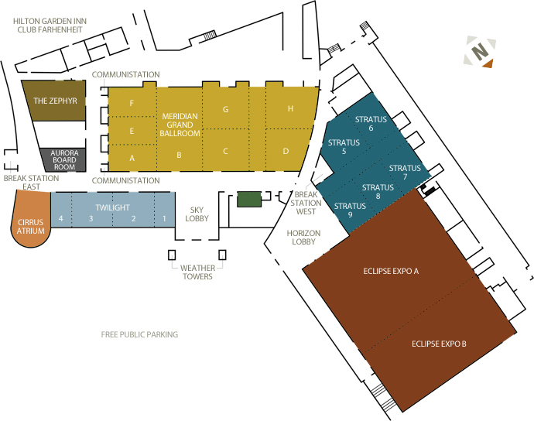

DAVIS CONFERENCE CENTER, LAYTON

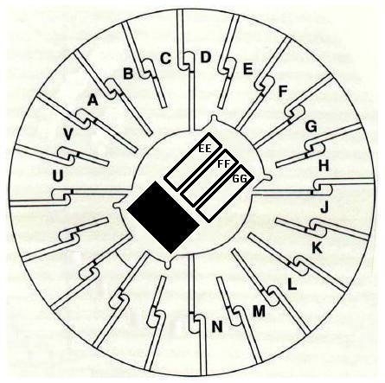

DEE EVENTS CENTER, OGDEN

MAVERIK CENTER, WEST VALLEY CITY

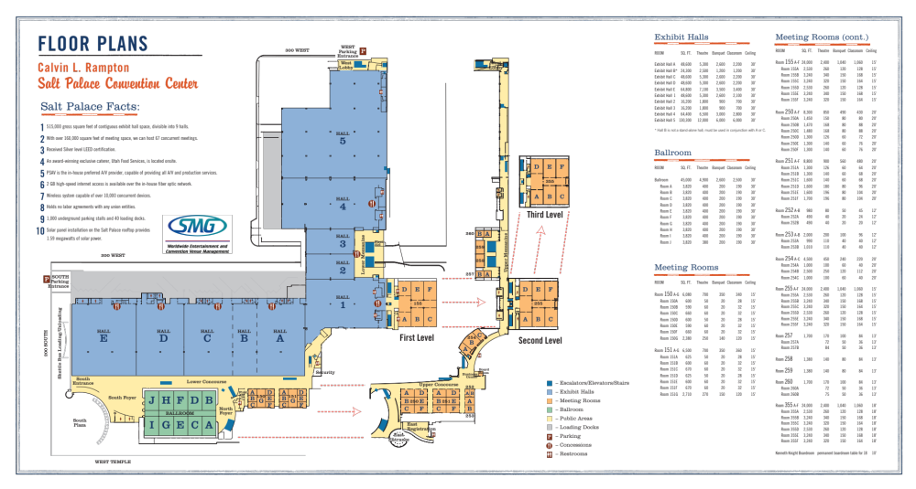
SALT PALACE, SALT LAKE CITY

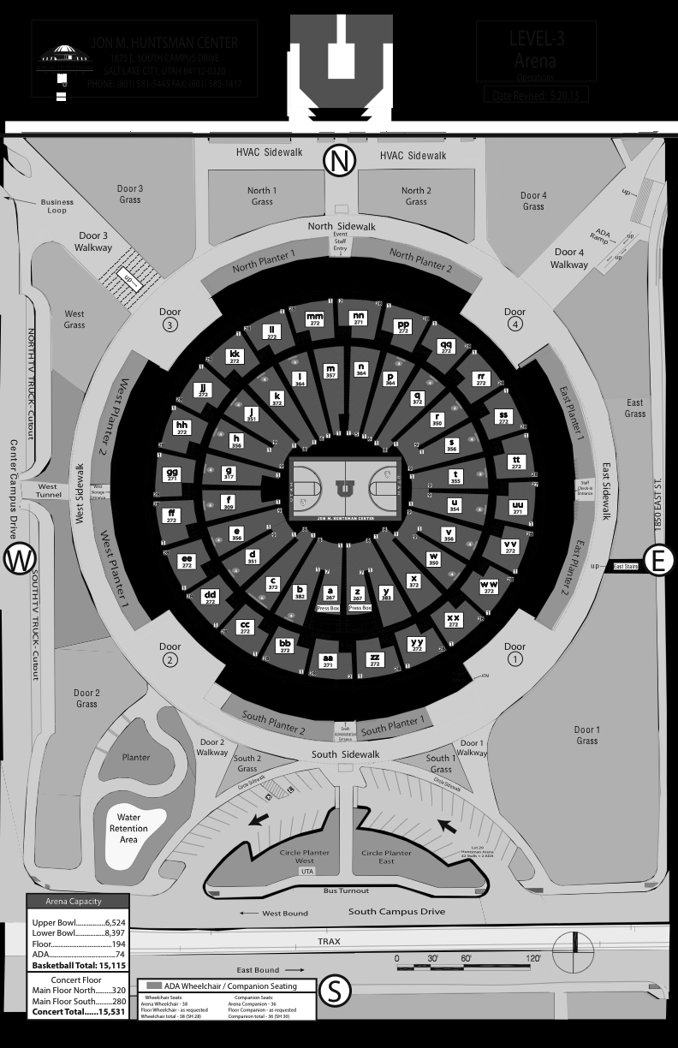
HUNTSMAN CENTER, UNIVERSITY OF UTAH, SALT LAKE CITY

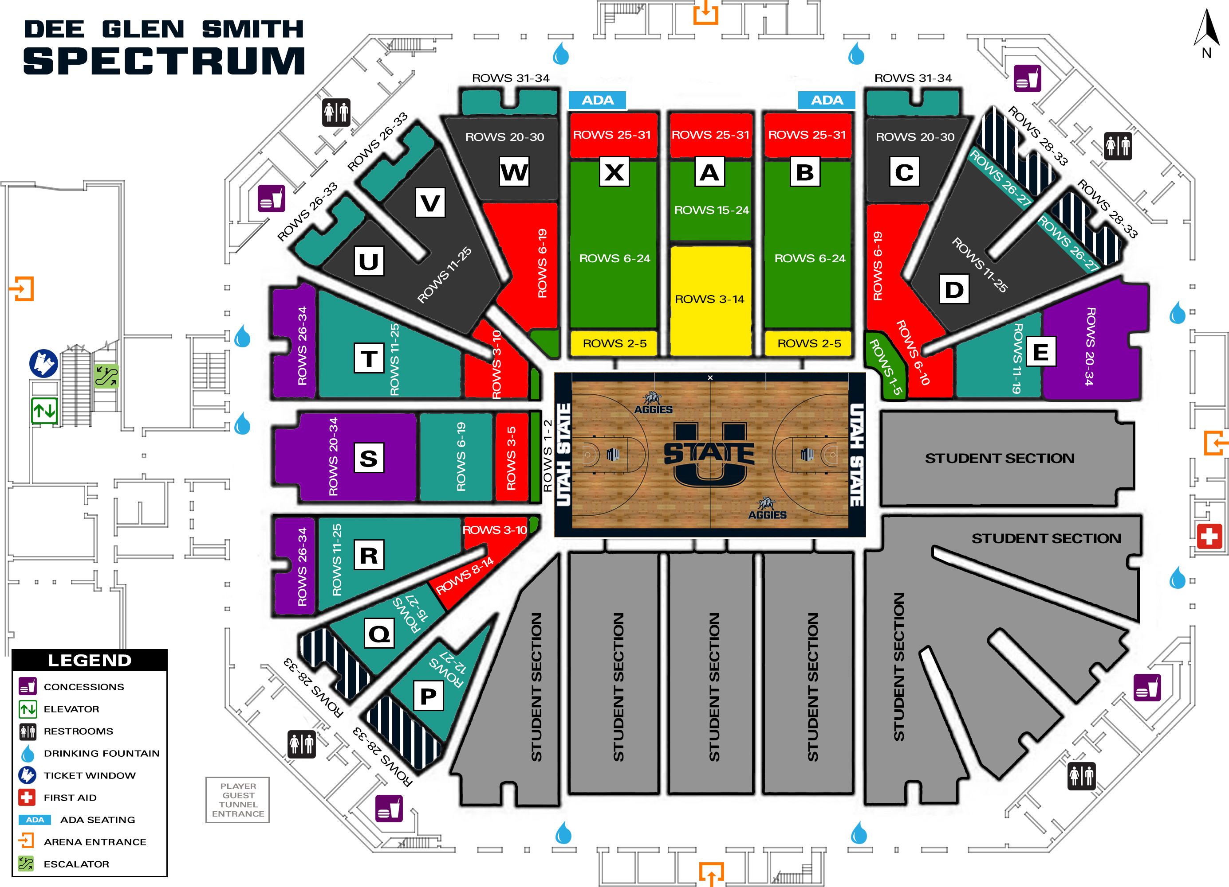
DEE GLEN SMITH SPECTRUM, UTAH STATE UNIVERSITY, LOGAN

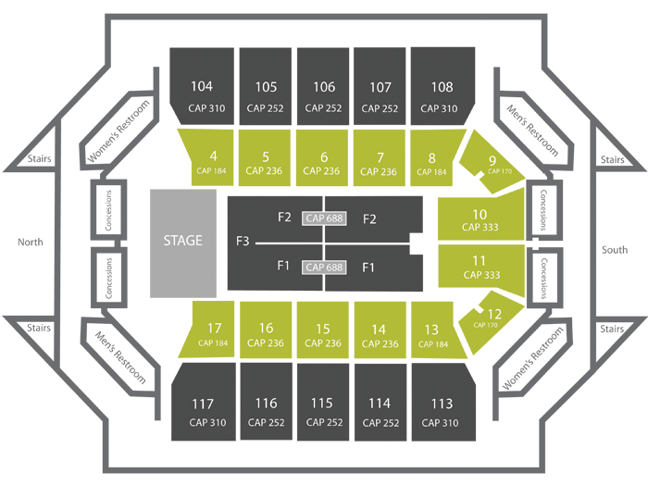
UCCU CENTER, UTAH VALLEY UNIVERSITY, OREM

NOTES

