FINDING A SEAT AT THE MANGEMENT TABLE:

DEFINING CURRENT ROLES, IMPLMEMENTATION, AND BARRIERS TO PUBLIC INFORMATION AS A PROFESSION IN GOVERNMENT
A capstone research paper submitted to the faculty of the Emergency Management Institute, Federal Emergency Management Agency, Department of Homeland Security,
for the course:
FEMA MASTER PUBLIC INFORMTION OFFICER PROGRAM
by

JESSICA N. SEXTON
City of Cape Girardeau, Missouri
August 2017

Abstract
Beyond the need for appropriate communications strategy and tactics, why is it that organizations fail at responses to day-to-day events even with key staff in place? The purpose of this study is to research what barriers lie to agencies adopting the public information role, how the role is misunderstood and misrepresented, possible implications for training and professionalism that will lead to effective Public Information Officer (PIO) role implementation and management buy-in for strategic communications and public affairs. To establish the current utilization range and understanding of the public information profession, I reviewed definitions of public relations, public information, and communications models. I surveyed individuals in the private and public sectors that are PIOs, who interact with PIOs, work in all levels of government, emergency management, public health, and related sectors. The 28-question survey included both qualitative and quantitative data points from 118 PIOs and related organizations’ management and non-management staff. Responses show that public information actively and rapidly evolving, but many jurisdictions are simply not equipped financially or with people to assist with the position. Therefore PIOs are considered a luxury by some, even when many agencies of all sizes have been staffing a PIO for years. Conclusions are made regarding the future need of defining the role of the PIO, empowering agencies of all sizes to begin or continue offering strategic communications to their publics beyond incident response.

Keywords: Public information, public relations, management, leadership, crisis communication0, risk communication, emergency communication, strategic communications, communications planning, communications tactics.
Table of Contents

Introduction 1
Project Overview 1
Communications/Leadership Strategies 2
Results and Findings 3
Lessons Learned 12
Summary 13
References 15
Appendix A 16
Appendix B 22

Introduction
Through many years of work, training and undergraduate study in the mass communications, public relations, and public information realms, one thing has stood out in my mind: Everyone communicates, but some will do so well and others will not do so well due to underestimation of its importance and other factors. Beyond the need for appropriate communications strategy and tactics, why is it that organizations fail at responses to day-to-day events even with key staff in place? While working to build a regional network of public information officers (PIOs) with colleagues, discussions led me to several key themes.
Many of the more than 120 members of our fledgling Southeast Missouri Information Officers Association were not full-time PIOs, to start, and have had no prior interest or specific training of working in the public information role. Networking and training with others in related roles has expanded interest and adoption of the PIO role in our region. The purpose of this study is to research what barriers lie to agencies adopting the public information role, how the role is misunderstood and misrepresented, possible implications for training and professionalism that will lead to effective PIO implementation and management buy-in for strategic communications and public affairs. This paper discusses an overview of themes I’ve encountered, an in-depth look at survey responses, and provides insight into potential future research related to the public information role on local, state, and national levels.

Project Overview
I chose this capstone project topic because of the gaps I see in PIO usage and misunderstanding of our capabilities and roles in my region. I worked to establish a baseline body of knowledge related to the challenges of how PIOs are used in organizations, what those who interact with PIOs consider crucial to the role, and where we stand currently as we look to elevate the profession and earn our “seat at the management table.” This status review of the public information role has important implications regionally and nationally. Through this project, I’d like to start gaining the appropriate measurements to help define a strategic direction for growing the recognition of the public information and public affairs professions, especially in government. How can we, as public information officers and leaders in our industry, plan to move the profession forward without codifying where we currently stand?

Communications/Leadership Strategies
To establish the current utilization range and understanding of the public information profession, I reviewed definitions of public relations, public information, and communications models. I surveyed individuals in the private and public sectors that are PIOs, who interact with PIOs, work in all levels of government, emergency management, public health, and related sectors. The 28-question survey included both qualitative and quantitative data points related to my research problem (see Appendix A for a list of survey questions).
I encountered several conditions and challenges during this research. Challenges included distributing the survey to appropriate respondents across the state of Missouri and elsewhere, making sure the non-scientific sample size of responses I received was diverse enough to draw conclusions for future research, and processing more responses than expected.
Additional challenges occurred when parties sharing the survey with colleagues did not forward off the Google link to access the survey. I was able to share the link with interested parties in these instances since I had controlled the number of outlets assisting with implementation. Other parties I’d asked to assist refused to send it to membership even though the survey targeted their audience, and others sent to a small number of colleagues as opposed to putting me in contact with appropriate parties of which to make the ask. Survey participants that work for the State of Missouri could not access the survey link from employer-issued devices and had to complete the survey on an alternate device.
As stated, the survey was circulated to various outlets around my jurisdiction, region, and state. Responses were anonymous unless the respondent chose otherwise. The survey was also completed by a few individuals across the Midwest and South. I wanted to incorporate feedback from folks in Missouri, but I chose not to limit geographical reach to provide additional opinions that could be of value to the national picture of PIO implementation. Southeast Missouri Information Officers Association members received a survey link by email and through our closed Facebook group.
The National Information Officers Association Region 7 Representative shared the survey with colleagues and posted to the group’s regional Facebook page. The Region E Coordinator for the Missouri State Emergency Management Agency received permission to share the survey statewide, allowing me to reach a large email database of professionals. Other Missouri colleagues in the Springfield and Saint Louis regions shared the survey link with key personnel and contacts in their areas. The survey remained open for responses for approximately two weeks. In all, 118 people responded to the survey (see Appendix A for a copy of survey questions).

Results and Findings
Survey questions one through seven asked participants for background and demographics-based answers including their professional title, years in their current position, organization type (government, non-government/nonprofit, private sector, or other), level of government, agency size, jurisdiction population size, and if the participant is management or non-management in their agency. Participants reported titles ranging from PIO and public affairs to media management, emergency management, city clerk, fire marshal, city attorney, chief and assistant chief, public health, agency administration, and department directors, among others. Other items to note about participants’ backgrounds included:
- 50% of the participants reported having spent less than five years in their current position, while less than 10% reported having more than 16 years of experience in their current role (see Appendix B, Figure 1).
- 66% of survey participants serve in a management or supervisory role (see Appendix B, Figure 2).
Participants were asked about their role in the public, private or nonprofit sectors. Nearly 90% of participants work in some level of government.
- In all, 65% work at the local level, 30% at the county level, 4% at the state level, and 1% working at the federal level (see Appendix B, Figure 3).
- Interestingly, 40% of participants noted having an agency staff of 50 people or fewer, while 45% noted between 100 and 500 employees (see Appendix B, Figure 4).
- Even though participants were from different sectors with 65% working in local government, 56% reported serving a jurisdiction of fewer than 50,000 people (see Appendix B, Figures 5-6).
Questions eight through 14 asked specifics related to agency PIO implementation, experience, and training.
- 60% of participants reported being a PIO for their agency, and 34% are not considered a PIO.
- Participants that serve as PIO mentioned a plethora of training and education sources, with 28 individuals having an undergraduate or graduate degree in public relations, mass communications, or journalism.
- Twenty participants have undergraduate or graduate degrees in communications or public relations and have completed some state or Federal Emergency Management Agency (FEMA) PIO training, while 16 participants received PIO training or degrees in other concentrations.
- Six participants have only completed some FEMA PIO training, and 8 mentioned on-the-job, unknown, or no public information training.
- One participant mentioned having an undergraduate degree in journalism, a Master’s of Business Administration, and the Accreditation in Public Relations (APR) designation.
The APR and APR+M designations are currently the closest system to credentialing for any part of the public relations profession and have strict criteria on professionalism and ethics as administered by a Universal Accrediting Board ("Why Earn Your APR?", 2017). Not surprisingly, many PIOs who participated in the survey have extensive professional communications backgrounds beyond job-related or FEMA training, making them well equipped to serve in their respective roles on a strategic and tactical basis.
Participants who are not their agency’s PIO were asked whether or not their agency has appointed someone to the PIO role.
- Most reported that their agency does have an assigned PIO, but 29% of non-PIOs stated their agencies do not have an assigned PIO or they plan to add that staff in the future (see Appendix B, Figure 7).
- Only 30% of participants stated their agency PIO is a full-time employee only serving in the public information role. Approximately 50% of participants stated their agency PIO is a full-time employee in another role, but serves in the PIO capacity when the duties are assigned.
- About 10% of participants mentioned their agency did not have an assigned PIO (see Appendix B, Figure 8).
- 35% of agencies with PIOs reported that they’ve utilized the role for 10 years or less, while more than 27% have had a PIO for 20 years or longer (see Appendix B, Figure 9).
Participants stating their agency has no PIO assigned were then asked to explain why and to state what would compel them to add the position. Responses to the former ranged from “no experience or training,” to “Presiding Commissioner does interviews,” to “just now getting on the social media bandwagon,” and “county officials do not see the need.” Others stated that a PIO may be added with board approval based on need, crisis situations, or for management to recognize the need and fund the position. One participant mentioned having an emergency response plan that includes public information, but they have yet to assign the role to key staff.
Responses to questions about adding the PIO position may show evidence of an underlying problem of showing to those in management roles the importance of the PIO. Where no PIO has been assigned, there is a potential for those who are nominated after an event happens to have never been trained or formally educated for the role. Pointing to social media and communications tactics as reasoning for not having an assigned PIO shows a clear misunderstanding of the public information role and what it provides other than responsiveness to emergency situations.
What could be creating this misunderstanding of the PIO role? Questions 15 and 16 asked participants to define “Public Information Officer” and “public relations” in an attempt to compare, contrast, and look for key themes when compared to established definitions. Definitions and descriptions for both public information and Public Information Officer are available in FEMA National Incident Management System (NIMS) courses and Incident Command System (ICS) glossaries.
The NIMS definition states that “Public information consists of the processes, procedures, and systems for communicating timely, accurate, and accessible information” on various incident-based criteria ("Course Summary", 2017). The ICS Glossary defines Public Information Officer as: “A member of the Command Staff responsible for interfacing with the public and media or with other agencies with incident-related information requirements” ("Incident Command System Glossary", 2008).
The Public Relations Society of America (PRSA) in 2012 worked internationally to provide an update to the definition of public relations concurrent with today’s professional standards. The PRSA crowdsourced definition is: “Public relations is a strategic communication process that builds mutually beneficial relationships between organizations and their publics” ("PR Definition: PRSA Official Statement”, 2012). According to PRSA, the definition focuses on public relations as a strategic process that “emphasizes mutually beneficial relationships,” and “counsels management at all levels in the organization with regard to policy decisions, courses of action and communication” ("PR Definition: PRSA Official Statement”, 2012).
While not an inappropriate description of PIOs, many of the participants defined “Public Information Officer” as an agency spokesperson or provided tactics-based descriptions of the role instead of a definition. Others provided a definition similar to the ICS description. Another key theme in the provided definitions was that the PIO responds to incidents. Few respondents mentioned any type of strategy related to the public information or public relations, and many seemed to confuse the two terms.
Public relations was defined by participants in relation to how an organization collectively interfaces with its jurisdiction. This type of definition is not surprising based on how public safety and emergency management organizations provide public education on a regular basis; however, those tactical public education items do not compare to the PRSA definition of public relations as strategic. Several participants included variants of spin and perception management in their definitions. One participant said: “Public relations is about defining a message and using every method possible to present that message to identified public parties or stakeholders. Defining goals, applying strategy, and measuring efforts are key parts of the process of public relations.” This participant-provided definition was the most closely associated to the PRSA-established professional definition of public relations out of all the responses.
Participants were then asked to describe the top services and resources they believe the PIO provides their organization. Most answers were tactics based, such as responding to media inquiries by “taking the brunt of media and public requests,” issuing situation updates in crisis situations, and providing timely information to the public. Others said they did not know what services the PIO provides. Many others mentioned the PIO as a spokesperson role and its relationship to ICS. One participant, a course instructor, mentioned that course participants frequently answer this question incorrectly during testing, and that the “correct answer is that he or she provides advice to the Incident Commander,” stating that that is the “most beneficial thing we do.” While beneficial, this points to both the public information role misconception among survey participants and a potential need to delve further into the capabilities of the PIO while completing NIMS training.
Meetings between communications staff and management happen frequently, with 72 participants stating they meet directly with key decision-making staff on a regular basis. Thirty-eight participants stated PIO meetings with management or key staff either do not happen, sometimes happen, or are not seen as a priority. Survey responses show that many participants believe a staff meeting suffices for a communications strategy meeting. Key components of building and executing a communications strategy are likely missed during these types of meetings by many participants. Several comments mentioned that communications planning and discussion are not seen as important “unless there is an incident occurring” (reactionary), or that leadership “thinks he’s too busy and does not seem interested in PIO activities.” Others noted that management and PIOs meet often, but operations still feel reactionary and that not all departments communicate with each other or the public when needed. Another key theme in the responses is that many do not see the need for a PIO in “the big sense” and that the need is “few and far between,” likely because of the misunderstanding that PIOs do more than respond to disasters and incidents.
When asked about communications planning, strategies and tactics used by their agency’s PIO, most participants mentioned tactical items like social media, posting content regularly, and traditional means of disseminating messages to the public. Others mentioned little to no pre-planning or strategy, while others mentioned having communications and strategic plans. Many stated their PIO activities “deal with problems as they arise.” Others responded that they see the PIO role as simply included in the agency crisis response plan, which serves as their communications strategy. Fewer than 20 participants mentioned using an agency communications plan or strategy outside of the risk or emergency plans, with one mentioning a regional plan.
Seventy-three participants felt that public information needs are a priority in their organizations, while 35 mentioned public information is not a priority or did not answer directly yes or no. One participant mentioned that public information is not seen as a priority because they are “not sure how to fully use this person” in the organization, showing a possible need for training for managers about the PIO position and how it can be implemented. It would be interesting to see which of these managers who do not see the role as a priority are not aware of the PIO Awareness course provided by FEMA, or who have already taken the course, in future surveys. One participant mentioned seeing public information as a priority but had previously mentioned their agency did not have a PIO.
Frustrations about the inability of public information staff to interface with management were evident through remaining survey questions. One participant mentioned that key management staff does not want to be proactive with messaging and wonders how information still gets out the public. Others mentioned needing to “use PIO in a proper way” in the future, pointing to a need to effectively define the PIO role and make sure it is communicated to key decision-making staff.
With both PIO and non-PIO survey participants, the biggest themes for the future of PIO in their organizations relate to funding, staffing, and an ever-increasing workload. Measurement and return on investment will continue to be a necessity. Many reported wanting to expand the organization’s communications role and work as a team. One participant said they hope PIO is “more respected and less seen as a threat to leadership.” Others mentioned working to incorporate strategic communications planning in the future.
Survey participants serving in management roles stated that PIOs need support, two-way communications, honesty, clear direction and role definition, training, and planning to be effective. PIO survey participants felt that they need buy-in for the role among departments and cooperation, open communication, authority to do their job, and trust. The most frequently-mentioned need by PIOs from management was support and the ability to operate autonomously in pertinent situations.
Participants reported agency staff members are completing PIO training early in their careers. About 75% of participants have been in their role 10 years or less, and 81% of participants reported having staff complete PIO training sometime in the last 10 years. Only 14% of participants reported their agency’s staff has not completed any type of PIO training.
When asked to list PIO training completed by staff, most answered with available FEMA courses or variations of the courses offered on a state and national basis. Variances in the list points to the need for a standardized training track to provide quality control for public information training offered by third parties or at the university level. Further research is needed to determine on whether or not any correlation exists between the education and training levels of PIOs and how that affects their “seat at the table” with management. Additionally, 88% of participants reported that they, or agency staff members, had completed NIMS ICS training in the past. A similar number of participants reported agency representatives completing PIO training. Since many participants had completed both, additional research should be completed to see if updated discussion of the PIO role is needed in the NIMS courses to aid in role clarity for management and incident command.
A parting question asking for additional thoughts on the role of public information netted 39 responses. Key thoughts from this section included developing greater respect for the profession by credentialing, certification, and role standardization. A participant mentioned that “many managers think they know ‘something’ about marketing/communications,” but the participant felt managers “did not have the expertise and skill sets to provide the best options” for dealing with situations where interpersonal issues complicate communications.

Lessons Learned
This survey provided insight into the role of the PIO in a manner that I anticipated. Responses show that public information actively and rapidly evolving, but many jurisdictions are simply not equipped financially or with people to assist with the position. Therefore PIOs are considered a luxury by some, even when many agencies of all sizes have been staffing a PIO for years. Based on survey responses, work should be done in defining the organizational role of public information in agencies of all sizes to empower them to begin or continue offering strategic communications to their publics. Many participants pointed to the PIO role as only being important during incident response. Additional research is needed to see if defining a PIO as important to crisis responses only is in direct relation to the description of a PIO in the command function under ICS in NIMS courses ("Course Summary", 2017). If so, exploration is needed into training updates to fully explain the strategic nature of the PIO role as public relations counsel for the organization and inclusion of the 95/5 concept as described by FEMA ("Public Information Officer (PIO)", 2016).
Efforts should continue to entice non-PIOs to complete PIO training to assist with role clarity. I would like to see both role definition and training focus more on public relations strategy and tactics as opposed to a one-way communications public information model historically utilized in government communications (Roberts, 2016). Considering a comparable option already exists in the private sector, PIO certifications or credentialing should be on the forefront of discussions for the public sector in coming years to establish professionalism and credibility ("Why Earn Your APR?", 2017).
Through this capstone project and survey, I will take with me a greater breadth and depth of knowledge about the perception and implementation of the public information profession. This will be beneficial when providing advice and training to colleagues around the state. Knowing more about existing barriers, I will be better able to advocate that more management staff complete appropriate communications training. Increased training by non-PIOs will aid in communications strategy becoming a forethought, not an afterthought, because public information staff cannot assist at the management table if management does not work to define and use the function or does not allow public information staff to provide counsel beyond everyday tactics.

Summary
Public information has been growing rapidly as a profession, yet both perceived and real barriers to proper role implementation still exist. My capstone project studied said barriers to adopting the PIO role in agencies of various sizes, how the role is misunderstood and therefore misrepresented, and possible implications for management buy-in for strategic communications. The project’s survey of 118 PIOs and related organizations’ management and non-management staff provided many insights into why public information does not have a prominent position in many organizations and an extensive role in others. Future iterations of this or similar surveys are needed to track changes in implementation and role clarity of public information over time. More robust data analysis can be completed once a strategy is defined going forward on how to steer the future of public information both here in Missouri, across the nation, and globally. Let us find our “seat at the management table” by implementing strategic, specific, and measurable goals for the public information profession in years to come.

References
Course Summary: IS-702.A - NIMS Public Information. (n.d.). Federal Emergency Management Agency. Retrieved from https://emilms.fema.gov/IS702A/PIOsummary.htm
Incident Command System Glossary. (2008). Federal Emergency Management Agency.
Retrieved from https://training.fema.gov/emiweb/is/icsresource/assets/icsglossary.pdf
PR Definition: PRSA Official Statement. (2012). Apps.prsa.org. Retrieved from http://apps.prsa.org/AboutPRSA/publicrelationsdefined
Public Information Officer (PIO). (2016). Federal Emergency Management Agency.
Retrieved from https://training.fema.gov/programs/pio/
Roberts, J. (2016). Writing for Strategic Communication Industries. Retrieved from https://osu.pb.unizin.org/stratcommwriting/chapter/four-models-of-public-relations/
Why Earn Your APR?. (2017). Praccreditation.org. Retrieved from http://www.praccreditation.org/value/why-earn-apr/

Appendix A
Survey: Looking at PIO Role Usage, Implementation, and Surrounding Issues

The following description and survey questions were asked of participants as described in the body of my research paper. Complete, unedited survey responses can be viewed at MPIO Survey Results (http://bit.ly/2vnbnFS).

Thank you for responding to this survey about public information and communications! Your responses assist me in researching my capstone project topic for FEMA's Master Public Information Officer program and will further the body of knowledge about the public information profession.

Please respond if you are a Public Information Officer, communications staff, agency management or in a supervisory role, work in emergency management or public safety, public health, work in education, or work in the private sector in a role that would coordinate with communications/public relations staff to disseminate messaging.

Your answers will remain anonymous. If you have questions about this survey, my research, or other topics, please feel free to contact me at jsexton@cityofcape.orgor 573-837-2286 (cell).

Please complete as many of the questions as you can; estimated time to complete the survey is 10-15 minutes. The survey will remain open for responses through end of business on July 28.

Your assistance is greatly appreciated!

Jessica Sexton
Public Information Specialist
City of Cape Girardeau

- What is your current title?
- Years in your current position
  - Less than 5
  - 5-10
  - 11-15
  - 16-20
  - More than 20
- Are you considered…?
  - Management/supervisory role
  - Non-management
- In which type of organization do you work?
  - Government
  - Non-government/nonprofit
  - Private sector
  - Other
- If you are a government employee, which do you serve?
  - Local government
  - County government
  - State government
  - Federal government
- Tell me about your agency’s number of employees (please estimate):
  - 10 or fewer
  - 11-50
  - 51-100
  - 101-500
  - 501-1,000
  - More than 1,000
- Tell me about your jurisdiction’s population size (please estimate):
  - 1,000 or fewer
  - 1,001-5,000
  - 5,001-10,000
  - 10,001-25,000
  - 25,001-50,000
  - 50,001-100,000
  - 100,001-250,000
  - 250,001-500,000
  - More than 500,000
- Are you considered a Public Information Officer for your agency?
  - Yes
  - No
- If you are the Public Information Officer, in what is your background training/education?
- If you are not the Public Information Officer, does your agency have one?
  - Yes
  - No
  - Not currently, but we plan to add a PIO in the future
  - I don’t know
- Is your agency's Public Information Officer(s):
  - A full-time employee working in the PIO role only
  - A full-time employee in another roll, but PIO as "other duties as assigned"
  - A part-time employee working in the PIO role only
  - A part-time employee serving in another roll, but PIO as "other duties as assigned"
  - Volunteer/unpaid
  - No PIO assigned
- If your agency does not have a Public Information Officer, please explain why:
- What would compel your agency to add a Public Information Officer, either as an additional staff member or by "other duties as assigned" with existing staff?
- How long has your agency had a Public Information Officer?
  - Less than 5 years
  - 5-10 years
  - 11-15 years
  - 16-20 years
  - More than 20 years
  - We do not have a PIO
- In your own words, please define/describe the term "Public Information Officer."
- In your own words, please define/describe the term "public relations."
- How often does your agency provide media and community outreach activities, or respond to information requests?
  - Multiple times per day
  - Multiple times per week
  - Monthly
  - Quarterly
  - Semi-annually
  - Yearly
- What are the top services and resources provided by the Public Information Officer to your agency? Or, if you do not have a PIO, what do you think are the top resources they'd provide?
- Does your Public Information/Communications staff meet regularly with management to discuss issues and strategy? Why or why not?
- What kinds of communications planning, strategies and/or tactics are being employed by your Public Information Office?
- Do you feel that public information needs are seen as a priority to your organization? Why or why not?
- What does the future for the Public Information Officer role look like in your agency and its departments/divisions?
- If you are in a supervisory role/management, what are the top 3 things you think your Public Information Officer needs from you to be effective:
- If you are the Public Information Officer, what are the top 3 things you need from your supervisors/management to be effective:
- Have you, or any of your agency's staff members, completed any type of Public Information Officer training in the past:
  - Less than 1 year
  - 1-5 years
  - 6-10 years
  - More than 10 years prior
  - Have never completed additional PIO role-related training
- If you or someone in your agency has completed Public Information Officer training, please list courses attended in the last 5 years.
- Have you, or any of your agency's staff members, completed any National Incident Management System/Incident Command training in the past?
  - Yes
  - No
  - I don’t know
- Do you have any additional thoughts about the role of the Public Information Officer, its usage during incidents or on a day-to-day basis, or otherwise?

Appendix B
Survey Charts and Graphs
Figure 1: Years in your current position. (116 responses)
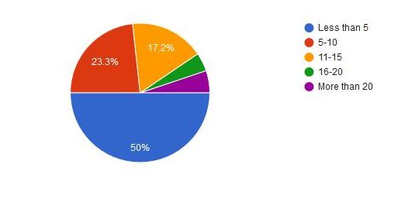
Of participants, 50% have spent less than 5 years in their current position, 23.3% have spent 5-10 years in their current position, 17.2% have spent 11-15 years in their current position, 4.3% have spent 16-20 years in their current position, and 5.2% have spent more than 20 years in their current position.

Figure 2: Are you considered a management/supervisory role or non-management?
(116 responses)
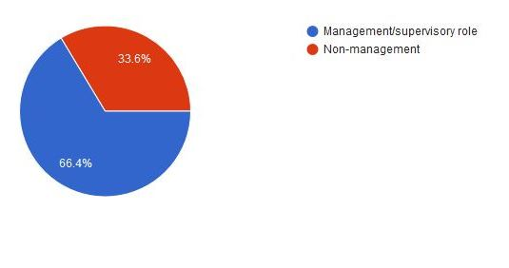
Participants said 66.4% serve in a management or supervisory role and 33% are non-management.
Figure 3: In which type of organization do you work? (116 Responses)

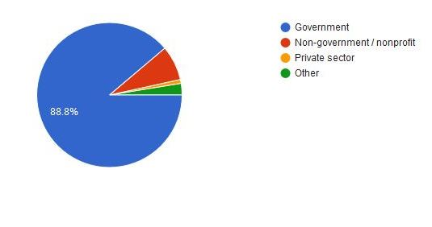
Participants work primarily in government agencies (88.8%), with 7.8% in non-government/nonprofits, 0.9% in the private sector, and 2.6% in other.

Figure 4: Tell me about your agency’s number of employees (please estimate). (116 Responses)

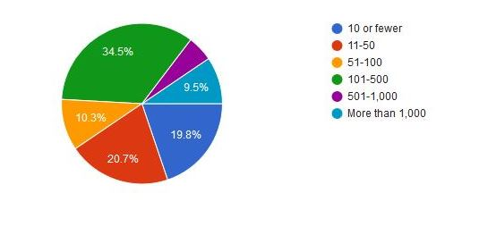
Participants report 19.8% work in an agency of 10 or fewer employees, 20.7% work with 11-50 employees, 10.3% work with 51-100 employees, 34.5% work with 101-500 employees, 5.2 % work with 501-1,000 employees, and 9.5% work with more than 1,000 other employees.
Figure 5: If you are a government employee, which do you serve? (104 Responses)

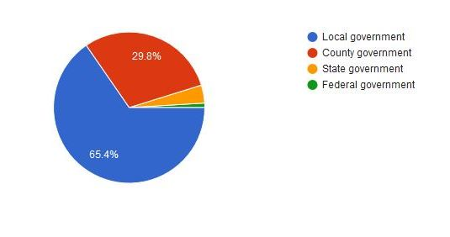
More than 65% of participants work in local government, 29.8% work in county government, 3.8% work for state government, and 1% work for federal government.

Figure 6: Tell me about your jurisdiction’s population size (please estimate). (115 Responses)
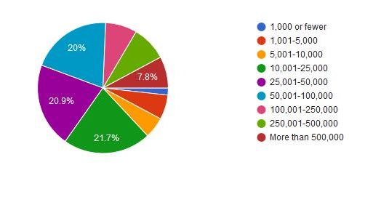
Under 2% of participants serve a jurisdiction with 1,000 people or fewer; 6.1% serve 1,001-5,000; 5.2% serve 5,001-10,000; 21.7% serve 10,001-25,000; 20.9% serve 25,001-50,000; 20% serve 50,001-100,000; 8.7% serve 100,001-250,000; 8.7% serve 250,000-500,000; and 7.8 % serve a jurisdiction with more than 500,000 people.

Figure 7: If you are not the Public Information Officer, does your agency have one?
(58 responses)
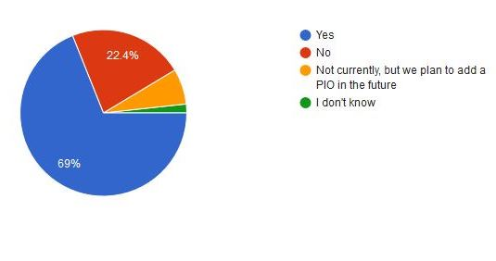
Sixty-nine percent of participants report that their agency has a PIO, 22.4% do not have a PIO, 6.9% do not currently have a PIO but plan to do so in the future, and 1.7% did not know if their agency had a PIO.

Figure 8: Is your agency's Public Information Officer(s): (115 responses)
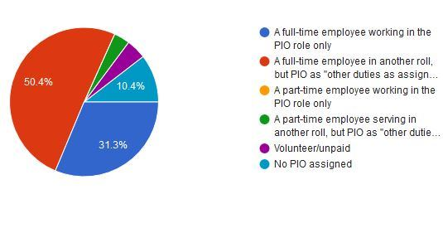
Of participants, 31.3% say their agency PIO is a full-time employee working in the PIO role only, 50.4% say their PIO are a full-time employee in another roll and PIO as other duties as assigned, 3.5% say the PIO is a part-time employee serving in another roll and PIO as other duties as assigned, 4.3% say their PIO is a volunteer or unpaid, and 10.4% said they have no PIO assigned.

Figure 9: How long has your agency had a Public Information Officer? (114 responses)
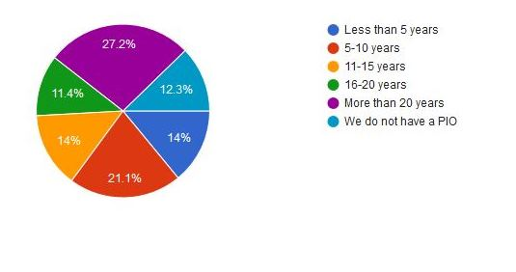
Fourteen percent of participants say their agency has had a PIO less than 5 years, 21.1% have had a PIO for 5-10 years, 14% have had a PIO for 11-15 years, 11.4 have had a PIO for 16-20 years, 27.2% have had a PIO for more than 20 years, and 12.3% stated they did not have a PIO.

