A Self-Assessment of How Well PIOs Function in a Joint Information Center
With Relationship to Levels of Training
Joel Gordon, Michael Jachles
Master PIO E0394
August 23, 2017

Abstract
Public Information Officers (PIOs) spend 95% of their time performing the business considered daily routines (Politano, 2015). Such tasks may include crafting press releases, promoting the organization, or managing media issues. Most PIOs feel they are well prepared to handle day to day operations. Five percent of the time, however, the PIO may be faced with a crisis or a major incident requiring skills and abilities not routinely employed in daily work. Current training programs for PIOs address this situation at a minimal level. There is a need, within the industry, for an expanded version of the current G-291, Joint Information Centers (JIC)/Joint Information Systems (JIS) course which teaches PIOs how to prepare for and respond to the five percent scenario. This paper will overview what classifies a five percent scenario, discuss the gap in the training, illustrate the perceptions of PIO’s regarding current training and JIC functionality, and make recommendations to improve upon the existing programs.

Thesis Statement
Public Information Officers and those who serve within the public information/public affairs disciplines feel they are well prepared to handle daily and routine tasks and assignments. However, there exists a gap between the Basic PIO course (G290) and training provided PIOs/PAOs to manage a crisis or critical emergency (E388). A robust course that introduces the skilled PIO/PAO to the tools, techniques, and practices of setting up and operating within a Joint Information Center (JIC)/Joint Information System (JIS) would serve as an excellent bridge between the current G-290 and E-388 courses offered by the Federal Emergency Management Agency (FEMA) (Federal Emergency Management Agency, 2017) .

Introduction
On August 13, 2004, a category four hurricane churning northward along Florida’s Gulf Coast had its sights set on Tampa Bay. Without warning, following a sudden right-hand turn, Hurricane Charley made landfall in Punta Gordo, Florida. The storm hit the small harbor-side community with winds more than 150 miles per hour (Wiltgen, 2015). Nine hours later Charley exited the Charlotte County area and headed in a northeasterly direction, ultimately exiting Florida’s peninsula near Daytona Beach.
As the sun rose on the Punta Gorda area, the next morning, the extent of the damage became clear. The predominantly mobile home communities were destroyed with shredded sheets of aluminum siding spread across leveled fields, wrapped around the few remaining trees and broken power poles, and littered Interstate 75.
Charlotte County’s Emergency Operations Center (EOC), an aluminum clad structure which was shared with the Sheriff’s Department, was left without a roof, power, or working plumbing (Nipps, 2009).
Hurricane Charley was the most devastating storm to hit Florida since Hurricane Andrew in 1992 (Wiltgen, 2015). In a fashion like Andrew very little infrastructure remained standing. The challenge for Emergency Manager Wayne Sallade was how to get information to Charlotte County residents where modern forms of communications no longer existed (Nipps, 2009). Through keen foresight when the Charlotte County EOC was designed Sallade worked with a local radio station to install an AM broadcast center in the EOC. Because of this, the radio station could broadcast immediately following the storm and issued messages and post storm information to the public, directly from the EOC. But how to get residents to go into their closets and find their old transistor radios was a challenge.
While sitting in front of the EOC pondering the question, two PIOs from Florida’s PIO Deployment Team observed activity across the street at the Charlotte County Airport. A pilot was checking on the status of his banner plane. The two approached the pilot and inquired as to whether he could fly. They arranged to have the pilot fly across Charlotte County with a banner that read, “1620 AM for Hurricane Info.” Within a few hours most Charlotte County residents had tuned in to the broadcast.
The definitive mission of the public information officer, during a crisis, is to get the right information to the right people at the right time so they can make the right decisions (Olshansky, 2015). The challenges for the PIO lies in what messages to put out, whom to send them too, what channels to send the messages over, and how to know the messages were received and understood.
The PIO position is well defined within the Incident Command System (ICS) (Federal Emergency Management Agency, 2013) and the tasks common to PIOs are somewhat defined within the National Incident Management System (NIMS). Current training for PIOs is provided through the Emergency Management Institute (EMI) in a series of on-line, extension, and resident courses (Federal Emergency Management Agency, 2017). The sequential offerings take a learner from a novice position with G-289, PIO Awareness and guide them through to the E-388, Advanced course. The G-290 course introduces the student to basic PIO skills. However, there is a significant gap between the G-290 and the E-388. G-291 provides the student with an introduction to JIS and JIC operations however, in the short time frame allotted for the course, the attendee receives little more than definitions as to standard JIC positions and functions.
When faced with an EOC activation and called upon to perform within one, there is little guidance or direction on what the PIO needs to do and a lack of standard procedures or a playbook as to the steps to take to get a JIC operation up and running.
The single most common complaint citizens voice after a disaster is a lack of accurate information or directions on what to do or where to get assistance (Donahue & Tuohy, 2006). Commonly Emergency Managers and Section Chiefs are focused on response and recovery efforts but crisis communications are frequently relegated to a single individual in a back room or offsite location. Both a physical and logistical disconnect occur, leading to the failure to effectively communicate (Donahue & Tuohy, 2006). Such failures can be seen in case histories of high profile incidents however are most notable in the performance of students during the Advanced PIO courses. At times students struggle through the course as they are unsure of what actions may be required or how to execute them. This often manifests itself in frustration, arguments, and in rare cases, emotional meltdowns.
Daily, most qualified PIOs can perform the requirements of their job. Crafting press messages, providing on camera interviews, and speaking at public forums are routine skills every PIO should have mastered (Politano, 2015).
The dynamic however, changes during a major disaster or crisis. The PIO is called upon, under highly stressful conditions, to perform at extremely high levels addressing issues for which they may have little or no experience. Along with the challenges of managing the high-pressure environment is the challenge of working within a large infrastructure, often with agencies they rarely work with, if at all. Each agency brings its own set of procedures and policies which may be in complete contrast to the way the PIO’s home agency works.
Knowing how to deal with such challenges does not develop inherently and cannot be left to experience. No actual playbook exists describing what needs to be done in a JIC. (Fig.13) Additionally, during the crisis is not the most ideal time to work through procedural differences.
According to Politano, opportunities for PIOs to work within a JIC occur approximately five percent of the time (Politano & Ol'Shansky, 2016). Some PIOs will never have the opportunity to work in a JIC (Fig 8.) The challenge, for the industry, is to capture such experiences and transfer them into an academic and reproducible document that can provide the newer or less experienced PIO with a guide to establishing and operating a JIC. (Fig. 13)
In 2005, armed with the experiences of the Storms of 2004, Florida’s PIOs, with direction from the Regional Domestic Security Task Force (RDSTF), undertook such a challenge. The Florida Department of Health (FDOH) funded by an RDSTF grant, engaged retired Florida Department of Law Enforcement Sergeant and PIO Mike McHargue to draft a document that would provide guidelines to all PIOs responding to major emergencies within Florida (McHargue & Gordon, 2005).
The Florida Association of PIOs (FAPIO), who operate the State’s PIO Deployment Team, were invited to attend the official release of the document (Florida Fire Chiefs Association, 2016). Through the State Emergency Response Plan (SERP) the Deployment Team had provided public information officers to every major incident in Florida since the brush fires of 1998 (Florida Fire Chiefs Association, 2016). It was at this meeting that both FAPIO and the DOH first learned that each agency had their own PIO response team. After much discussion and several side meetings it was determined that McHargue would work with a representative from FAPIO and redraft the document to more align with Florida’s well established, State Emergency Response Plan (SERP) (McHargue & Gordon, 2005).
The exercise illustrated the power of building partnerships as the final document was a conglomeration of both SERP and DOH procedures, built under the guidelines established through the Department of Homeland Security’s (DHS) NIMS and ICS training documents (McHargue & Gordon, 2005). Included within the text were operational models for the 15 National Planning Scenarios (Federal Emergency Management Agency, 2008). The document was approved and ultimately adopted by the RDSTF, SERP and the Florida Fire Chiefs Association (FFCA) (Florida Fire Chiefs Association, 2016).
In 2008, following Florida’s experiences in Mississippi with Hurricane Katrina in 2005, the Florida Joint Information Center Guidelines were rewritten to include components of the Emergency Management Assistance Compact (EMAC) and new technologies (McHargue & Gordon, 2005).

Research
The primary purpose of this paper is to illustrate the need to close the gap between the G290 Basic PIO course and the E-388 Advanced PIO course. The thesis statement identifies that the current G291 JIC/JIS course may not be adequate to prepare PIO students for the advanced program. As part of the process to validate or disprove this theory data reflecting PIO related experience, training, and confidence working a large-scale incident was collected via a 16 questions survey. Participants in the survey were sought through a database built by FAPIO in a software system known as Collabria. The system is used as a database for national, state, regional, and local email lists and notifications. The same system is used to deploy PIO resources when requested via the SERP.
Questions were constructed to collect demographics on the participant’s job responsibilities, years of experience, and levels of training. Additional questions evaluate the participants’ personal assessment of their readiness to respond to a major incident and areas in which they detect system gaps.
Three groups were surveyed: Nationwide, State of Florida, and Florida RDSTF Region Seven. While these groups were selected because of their existence within the software group listings, they are also significant in that Florida has a high occurrence of major incident responses. Region Seven is one of the most densely populated regions in the State and maintains the highest number of recognized PIOs in Florida.
Each question is presented in comparison between the three groups. Respondents from one group have been removed from the other two to ensure no duplication.

Findings
The respondents within the survey groups appeared to show consistent patterns in their responses to specific questions. The patterns however, may be a factor of the target group’s structure rather than a true measure of the industry. Further research into this issue may be required.
Demographics breakdown:
The survey was published to 2,325 names on the Collabria list. There were 525 in the RDSTF Region Seven list, 900 on the Florida list, and another 900 on the national list. Returns from the survey yielded 133 respondents from Region seven or 25%, 128 from Florida resulting in 14%, and 187 nationally, equaling 21%.
65 % of the total respondents identified themselves as a PIO or PAO while much smaller percentages served in other related capacities such as marketing, public relations, or otherwise undefined.
Most of the respondents reported working for Fire/EMS, Law enforcement, or Emergency Management agencies. The fourth largest category was a non-specific government category.
As to the questions of job related experience nine percent of the respondents claimed at least five years of experience working in their current or similar position while four percent had only one to two years of experience (Fig 3).
In contrast to the above data when questioned about their experiences working within a joint information center 77% nationally indicated they had done so. However, the two Florida categories indicated less than 50% of the respondents had any JIC experience (Fig 8). It should be noted the survey did not break down nor define what was meant by “working in a JIC.”
Two factors of inexperience in a JIC are often captured anecdotally as the PIOs comfort level and an understanding of their role. The survey attempted to evaluate the reality of these factors by asking the respondents who had worked in JICs to identify both their comfort levels and an understanding of their roles. Nationally 55% of the respondents identified themselves as being comfortable working in a JIC with well-defined roles. Within the smaller groups of Florida and Region Seven 29% and 21% respectively identified themselves as being comfortable and knowing their roles (Fig. 9).
Working response plans:
The data begins to show inconsistencies when assessing the PIO’s knowledge of a working response plan. While a significant majority responded they had JIC experience (fig.8) and were comfortable working in a JIC (fig. 9) Nationally 36%, 49% in Florida, and 66% in Region Seven were unaware of whether they were working from an established JIC plan. In all three groups, a significant number also did not answer the question which may be associated with not knowing. These responses were indicated separately (fig. 13).
Training:
The scope of this paper is an attempt to identify whether the existing training provided for PIOs is adequate to prepare them for the tasks they must perform both at the 95% level and the five percent level. Respondents were questioned about the highest level of training they have taken. Nationally 42% of the respondents indicated completing E-388, Advanced PIO. Florida showed the majority or 32% of the respondents completing only G-290, Basic PIO, while Region Seven respondents showed a 29% completion rate for the Advanced course (fig 6). This spike in the training level in Region Seven may be the result of two recently completed, L-388 classes within the Region and a strong push by the South Florida Media Coalition to get all its members certified to that level.
The analysis of the effectiveness of the training was captured across three questions: 1) How well did the training prepare the respondent for daily duties, 2) Which training best prepared the respondent for JIC activities, and 3) What type of additional training would be of value to the experienced PIO.
In response to the question of applicability to their daily duties 65% nationally, 42% in Florida, and 46% regionally indicated the training prepared them well for daily duties. It also bares mentioning that a small number (statistically insignificant) indicated their best training was “On the job” training (fig. 7).
When asked about the applicability of their training to JIC preparedness both Florida groups indicated the Advanced class served them best. In contrast, the G291 JIC/JIS course was the highest rated for the National group. A striking result of this question was that most of the respondents indicated that none of the courses prepared them for JIC activities. 37% Nationally, 51% in Florida, and 50% regionally indicated none, no answer, or not applicable as responses to the above question.
In terms of future training needs results varied widely between the respondent groups. Options provided were: Crisis management, news conference planning and logistics, news release writing, in-depth, on camera interviews, photo/video techniques, and social media. In both the national and regional groups, the choices were almost evenly distributed, Crisis management was the highest nationally (90%), and second regionally (85%) falling slightly behind social media (69%). Statewide, the Florida group indicated an overwhelming need for in-depth, on camera work (54%) (see fig. 16). Respondents could provide multiple answers to this question.
The study also reviewed the responses as they related to years of experience. As could be expected the five years or greater group expressed the most comfort and functionality in a JIC, while those with lesser time showed less confidence. (Those charts are not included in this document.)

Recommendations:
By expanding the G-291 from an eight-hour program to a full two-day course using an overlay like the Florida JIC Guidelines, coupled with a functional or tabletop exercise would provide the student with a practical frame of reference in preparation for enrolling in the E-388 Advanced PIO course. The lessons learned within the high-pressure framework of E-388 would be better absorbed, with less angst as most of the building blocks have already been laid.
The current JIC Guidelines are scheduled for another rewrite beginning in late 2017. This is an ideal time to review the contents of the document as they align with FEMA’s educational goals and retool G-291 to better prepare the students for future opportunities. The two projects could be undertaken simultaneously as those involved in the Florida project have successfully completed all the PIO curricula provided by FEMA.
Certification:
It is outside the scope of this paper to discuss certification and credentialing of public information officers however, as this has become a topic of discussion at the Master PIO level it bears a footnote. Currently there is no recognized certification for PIOs. The Fire Service provides testing and certification for virtually every other position within the ICS structure other than PIO. The need for PIOs to have a credentialing and certification process is critical to establishing themselves as an essential entity.
By enhancing G-291, coupling it with G-289 and G-290, a pathway is being constructed for information officers across the nation to follow the same processes and established practices. These are the components at the very core of certification. Once drafted it may be in the best interest of the profession to submit the process to a credentialing body and establish a pathway to certification.

Conclusion
95 percent of a PIO’s daily responsibility involves routine communications activities that may run the gamut of media relations, risk communications messages, internal messaging, and social media management. Almost all PIOs have the rudimentary skill set needed to manage those daily activities.
It is however, the other five percent that puts demands on newer or less experienced PIOs that may push them beyond their capabilities and lead to catastrophic failures. Except for hurricanes or pandemic outbreaks crisis rarely provide extended notice. The ability of a single PIO to ramp up activities into an emergency management role takes training, experience, and a few slips down the rabbit hole.
This study compared and contrasted communications professionals from a broad spectrum of disciplines, geographic regions, and years of experience. Based upon those demographic factors respondents were queried about their training, JIC experience, and comfort levels working in JICs. Eliminating those who identified as having no JIC experience (35%) a pattern emerges in which longevity brings greater experience and comfort levels. In hindsight, the question not asked was the number of times in which the respondents served in a JIC.
The thesis statement suggested a relationship between the G-291 course and the respondent’s preparation for JIC operations. It suggested that the limits of the course may create a gap in JIC training among PIOs. The reported data reflects the contrary. Most respondents felt the G-291 or the E-388 courses were adequate in preparing them for working in a JIC.
What is not assessed as a scope of this paper however, are the quality of the JIC products during those operations nor the outcomes from those events. As there is no evaluation scale for such events, documenting this is also a subject for more research. While many of the respondents may feel they functioned well, historically events such as the Pulse Nightclub shooting, or Hurricane Katrina in New Orleans may not have been managed as well as an incident such as the Boston Marathon Bombing which has been described as one of the most successful JIC operations to date (Lowery, 2013).
Beefing up FEMAs G-291 course as a method to prepare the novice PIO for JIC activities is but a starting point. The PIO must appreciate the value of building partnerships before a crisis strikes. Understanding the roles and needs of other agencies as they relate to public information and working from a comprehensive, well vetted playbook that provides guidance during and after the event are two essentials to effective JIC operations.
Once PIOs achieve these levels of expertise, proven themselves both academically and practically, and shown a true desire to “play well in the sandbox” can they truly be considered a qualified Public Information Officer. It is at that juncture that a recognized and adopted certification can and should be issued.

Addendums
Fig. 1: Best description of primary position.
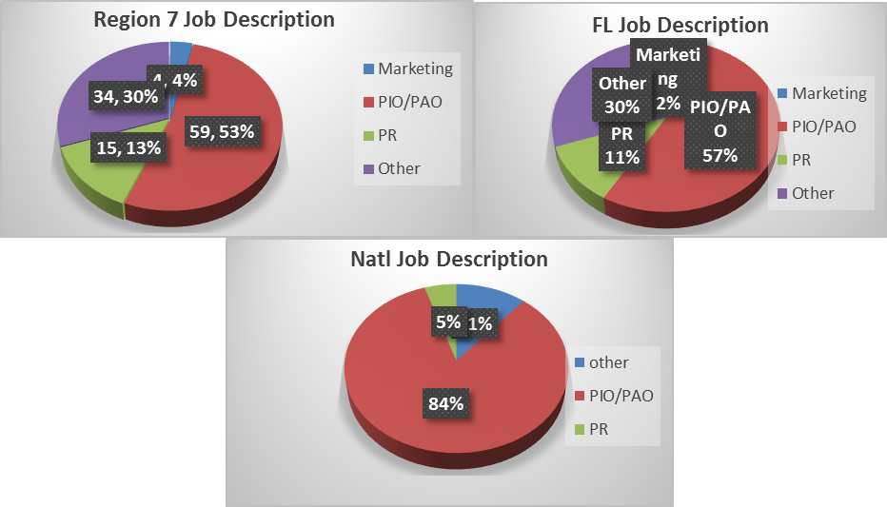

Fig. 2: Agency type:
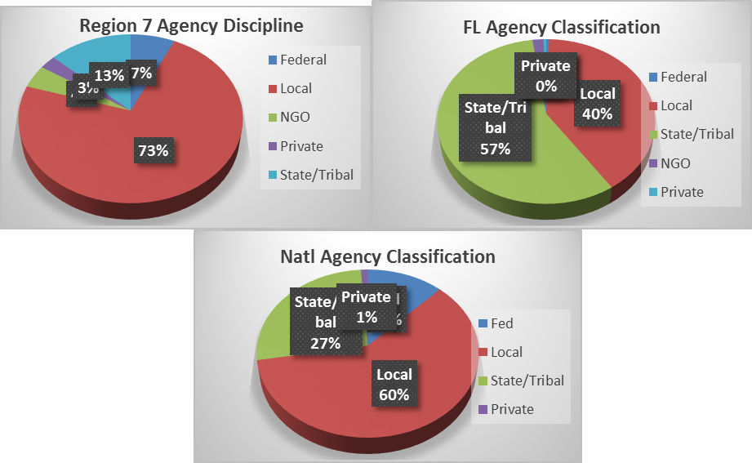

Fig 3: PIO job tenure.
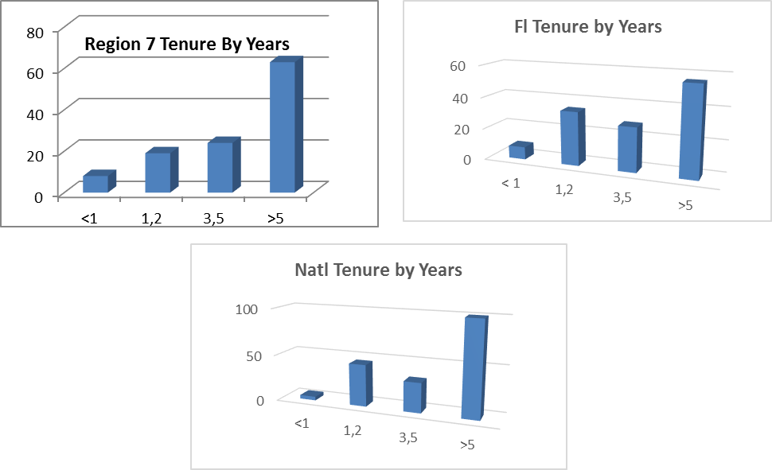
Fig 4: Agency discipline:
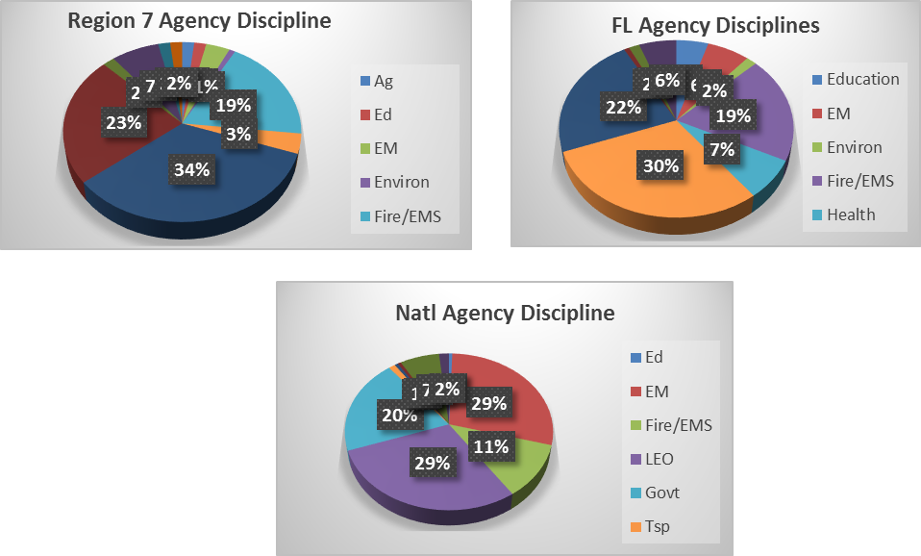

Fig 6: Highest level of PIO training completed
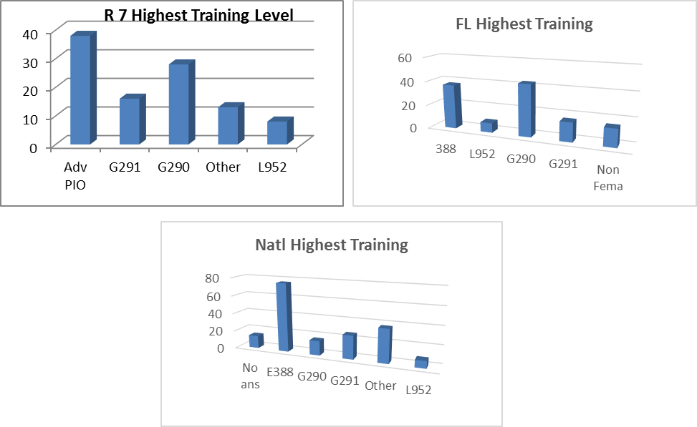
Fig 7: How well has PIO training prepared you to do your daily job?
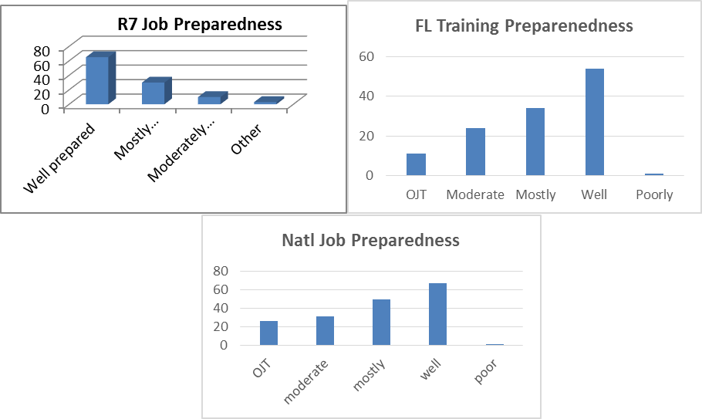
Fig 8: Joint Information Center experience?
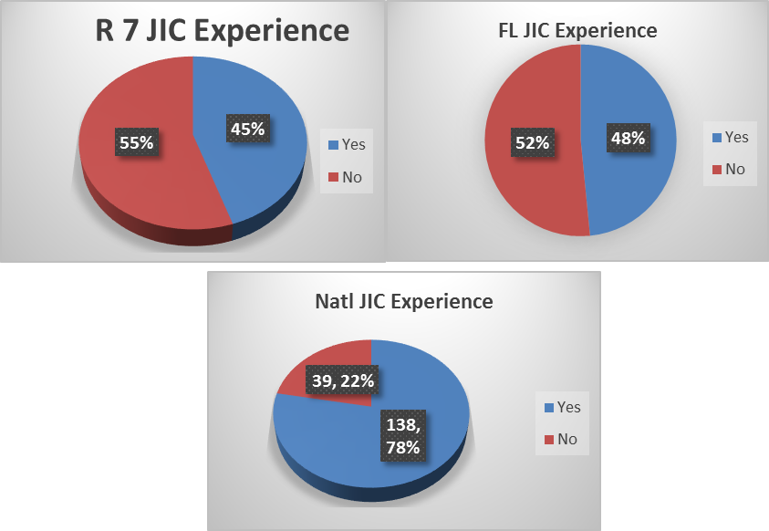
Fig 9: Comfort with your role in the JIC?
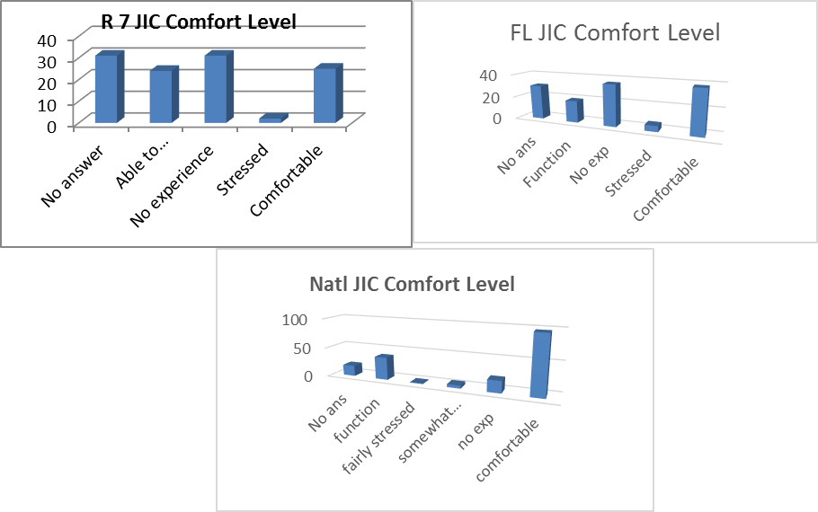

Fig 10: Which PIO course provided best preparation to work in the JIC?
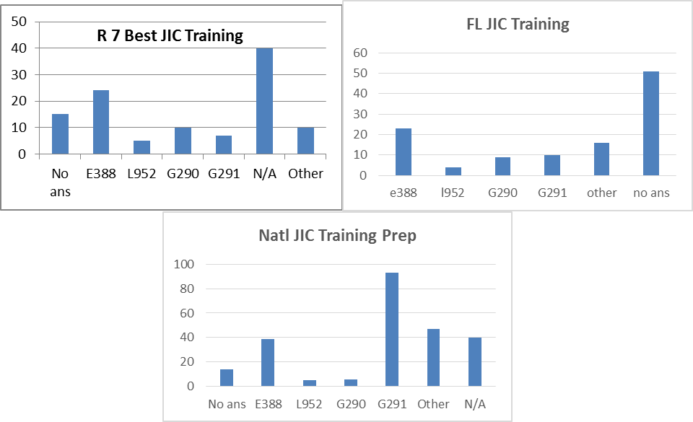
11) What PIO related groups of Associations do you belong to?
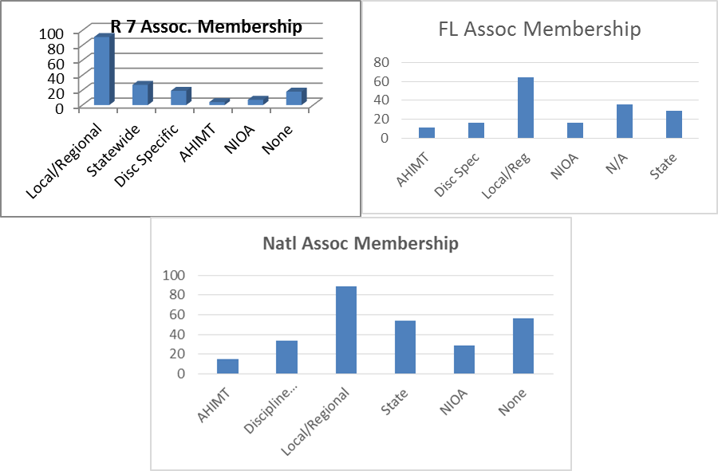

Fig 13: PIO Associations with established emergency response plan
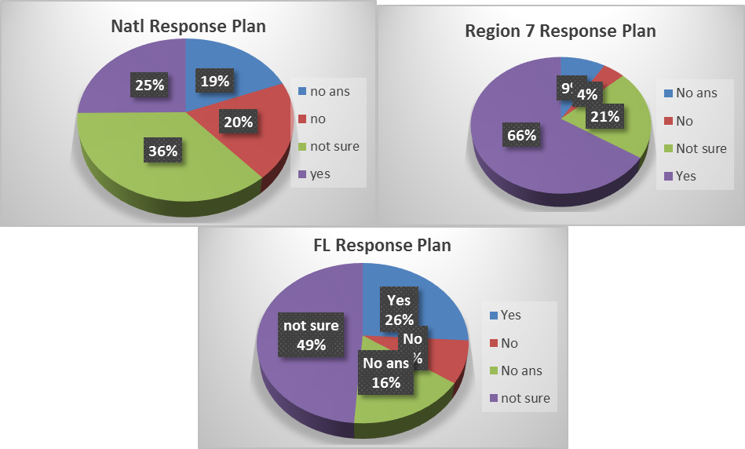

Fig 14: How well-defined is the PIO’s role in the emergency response plan?
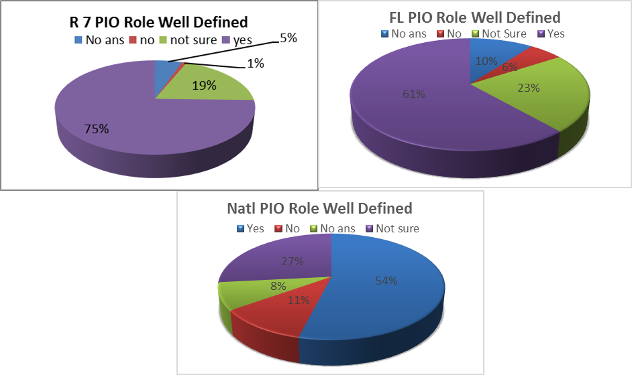
Fig 15: PIO utilization role during a crisis/critical incident.
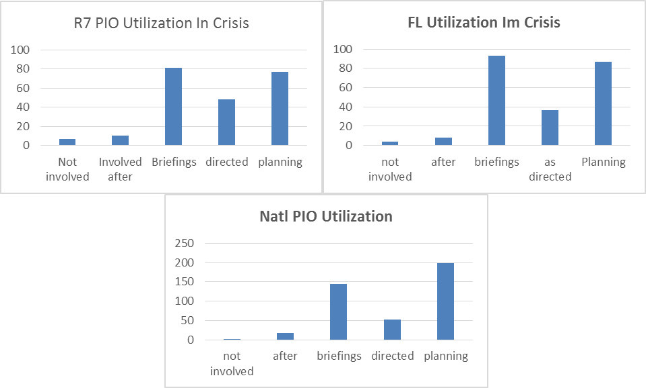

Fig 16: Key topics desired in revised JIC/JIS curriculum:
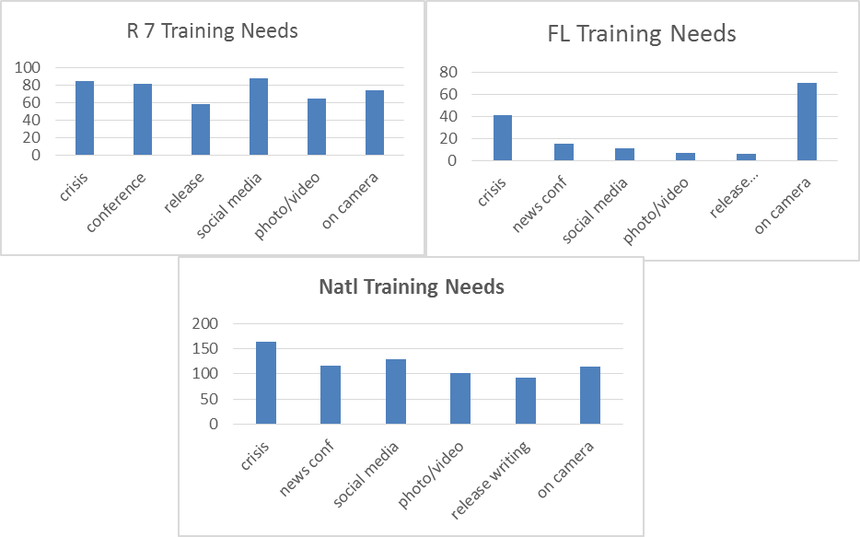
Bibliography

Federal Emergency Management Agency. (2008, January). National Response Framework. (Retrieved from FEMA.gov: https://www.fema.gov/pdf/emergency/nrf/nrf-core.pdf)
Federal Emergency Management Agency. (2013). Command Staff Functions IS 200. (Retrieved from FEMA.gov: https://emilms.fema.gov/IS200HCA/ICS0104060text.htm)
Federal Emergency Management Agency. (2017, March 2). EMI Courses. (Retrieved from FEMA Emergency Management Institute: https://training.fema.gov/emicourses/)
Florida Fire Chiefs Association. (2016). Statewide PIO Deployment Team. (Retrieved from FAPIO.org: http://www.ffca.org/sections/Public-Information-Officers.html)
McHargue, M., & Gordon, J. (2005, October 12). RDSTF Joint Information Center and Joint Information System Protocols. (Retrieved from FAPIO.org: http://www.ffca.org/sections/Public-Information-Officers.html)
Olshansky, T. (2015). Strategic Communications. G-290 Basic Public Information Officer. Federal Emergncy Management Agency.
Wiltgen, N. (2015, August 24). Strongest Hurricanes: 10 Most Intense Atlantic Hurricanes on Record. (Retrieved from Weather.com: https://weather.com/storms/hurricane/news/strongest-hurricanes-most-intense-atlantic-hurricanes-20130911#/8)

